*Lab 4: Transistors*

Physics 411

John Waczak

11/17/2016

Lab Partner: Kyle Tafoya

Background

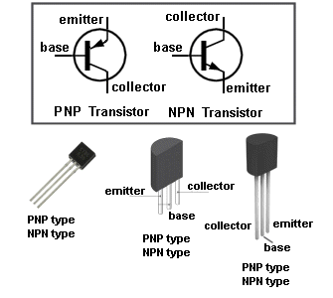

Figure : Common transistors1

Lab four examined the physical characteristics of the transistor. As mentioned in the lab guide, the transistor is the first ‘active’ component we’ve studied as opposed to the ‘passive’ resistor, capacitor, and inductor. The transistors have 3 pins shown evidenced in their circuit diagram shown in figure one to the right. They are labeled the base, collector, and emitter. Similar to the diode, the transistor relies on doped silicon to create regions of ‘positive’ (holes) and ‘negative’ carriers that determine how current flows between the collector and emitter pins when the base pin is biased with a small current.

There are two main configurations for the transistor: PNP and NPN which correspond to how the regions around the pins are doped as described above: P for positive and N for negative. There are many different types of transistors; this lab exclusively used the Bipolar Junction Transistor hereafter referred to as a ‘BJT’. The BJT was the first type of transistor to be mass produced and thus is one of the most commonly used transistors in proto-board electronics.

Transistors are useful as relatively small currents, such as those that can be supplied by microcontrollers, can be used to control larger devices that draw much more current between the collector and emitter. In this way they can act like on off switches and have thus become the fundamental building block for modern digital electronic devices.

Lab 4 analyzed the workings of the 2N3904 npn and 2n3906 pnp transistors through 3 experiments. The first analyzed the ‘diode drop’ across the different combinations of pins. The second analyzed the base bias that is introduced to the output signal when using the transistor as well as the property called signal clipping (as well as two methods to correct this). Finally, the third experiment demonstrated how an input signal can be used to control the current to an external load via an LED. The specific methods as well as the results of the experiments will be the subject of the following lab report.

Experimental Procedure

1. *Transistor basics*
2. **Diode Drops:** A simple model for a transistor is that it is essentially two diodes. Thus there is a ‘diode drop’ corresponding to the voltage drop across a combination of pins that are forward biased. In experiment one, we measured the diode drop using the ‘diode’ setting on the digital multi-meters in the lab. We measured the diode drop across all three combinations: base-collector, base-emitter, collector-emitter for the npn transistor.
3. **Transistor gain 1:** The gain of a transistor is simply the ratio of the current output through the emitter versus the input current to the base. This gain is the factor by which the base current is amplified. In general, this can be modeled by the equation:

$$I_{B}=βI_{C}$$

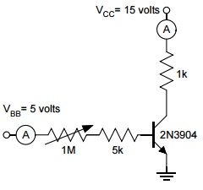Where beta is the gain. Part (b) of experiment 1 had us measure the gain using the HFE setting on the digital multi-meter for each of the two transistors. The transistors simply fit into a slot on the device marked with the type – either NPN or PNP.

Figure : Determining the transistor gain using 2 ammeters

1. **Transistor gain 2:** The final part of the lab had us measure the gain for the 2N3904 by measuring the current drawn to the collector and to the base using two ammeters. A potentiometer was added in series to the base in order to allow us to vary the input current. Figure 2 shows the circuit diagram used for the experiment.
2. *Emitter Follower*

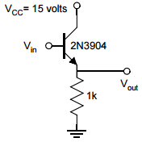

Figure : Emitter - Follower circuit

1. **Base Bias:** The first application of a transistor in a simple circuit we tested was the “Emitter-Follower” configuration. Figure 3 below shows the circuit diagram for our construction:

The idea of the emitter-follower is that the output signal should match the input (i.e. no phase shift). We were tasked with sending an input sinewave and determining the minimum amplitude required to cause an output. Then we increased the amplitude of the input wave and measured the difference between the amplitude of the input, and the output signal.

1. **Signal Clipping:** After completing part (a) of the lab using the emitter-follower circuit, we noticed that the output signal was ‘clipped’ meaning that only half of the signal made it through the transistor to the emitter. This resulted in the output signal only having positive values and being zero where the input signal had negative values. Part (b) asked us to test two possible solutions to this problem shown in figures 4 and 5.

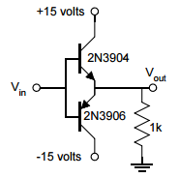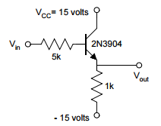

Figure 5: Solution 2 to clipping problem

Figure 4: Solution 1 to clipping problem

In the circuit shown in figure 4, a 5kΩ resistor was added in series with the base to pull the input current down. Where previously the emitter was connected to ground, this was then changed to -15 volts in order that the negatvie half of the output signal might be observed. The idea behind adding the resistor is to decrease the input current so that the entire gain can be observed (where generally this was limitted by the 15 volt supply).

In circuit 5, -15 volts was also used to replace the ground however a typte pnp 2N3906 transistor was connected such that the bases were common and the emitter of the NPN was connedted to the collector of the PNP and then to ground. Theoretically then, when the input is postive, only the NPN (above) will be forward biased, so we should see the postive half of the signal on the output. Then when the input is negate, the NPN becomes reverse-biased thus eliminating positve output while the PNP transistor becomes forward biased but from 0 to -15 volts. This ‘recovers’ the negative half of the output signal, hopefully eliminatign the clipping problem.

Both circuits were tested and observations were recorded.

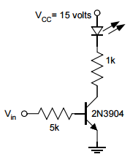

Figure 6: The LED blinker circuit

1. *Transistor Switch*
2. **LED switch**: The third and final experiment in the transistor lab examined one example of a practical use for the transistor – an electrically controlled switch (non-mechanical). Figure 6 shows the circuit diagram in which an input square wave is used to ‘turn on and off’ the path for current to travel from the collector by periodically reversing the bias on the base pin. We were asked to find the amplitude required to be able to turn on the LED. Then both high and low frequencies were used in order to characterize the behavior of the ‘switch’.

Data

1. *Transistor Basics*
2. **Diode Drops**: Table 1 below shows the data for the diode drop across the various pin combinations for both the 2N3904 transistor and for the 2N3906.

Table : diode drop voltage

|  |  |  |  |  |  |
| --- | --- | --- | --- | --- | --- |
|  | **Diode Drop (Volts)** | |  |  |  |
| **Pin Combination** | 2N3904 (NPN) | 2N3906 (PNP) |  | Collector = | 3 |
| 1,2 | Overload | -0.649 |  | Base = | 2 |
| 1,3 | Overload | Overload |  | Emitter = | 1 |
| 2,3 | 0.646 | -0.641 |  |  |  |

As you can clearly tell, for the NPN transistor the only measurable bias was for the base and collector. This makes sense as the bias on the base controls the current between the collector and emitter and we want the current to flow from the collector to the emitter.

By the same logic then, it makes sense that the PNP configuration should show the opposite results as the physical configuration has been reversed. However, both my lab partner and I were confused as to why the reading was for a negative voltage. Perhaps this is because for the PNP transistor a reverse bias to the base causes the current to flow from the collector to the emitter i.e. to get the current to flow in the same direction as for the NPN we need to have the opposite bias to the base which results in a negative reading.

1. **Transistor gain 1**: Using the Hfe setting on the digital multi-meter, the gain for the 2N3904 transistor was measured to be 136 and the gain for the 2N3906 was measured to be 280. These are within reason as the reported values were between 150 and 300 for the 2N3904 and 300 for the 2N3906.
2. **Transistor gain 2**: As mentioned previously, part (c) had us measure the gain of the 2N3904 for various input currents by measuring the base current and collector current using two ammeters. Graph 1 below shows the graph of the collector current as a function of the base current.

Graph : Measuring the transistor gain

The gain is simply the ratio of I(collector) to I(base) which is equivalent to the slope of the I(b) vs I(c) graph in graph 1. As the R^2 value of the best fit linear trend line was 0.9976, we can safely say the we measured the gain to be 138.39 (the slope of the trend line). This value is consistent with our measurement in part (b) which was 136 and falls within the range listed in the spec sheet.

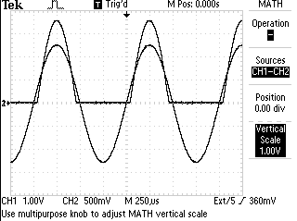

Graph Signal Clipping - Emitter Follower circuit

1. *Emitter Follower*
2. **Base bias**: After building the emitter-follower circuit described previously, we found that the minimum amplitude required to cause an output voltage was 1.200 V pp which corresponds to an input voltage of 0.600 volts. This makes sense as this value is very near the diode drop value measured in experiment 1. Graph 2 to the right shows a capture for the input and output signals for the emitter follower circuit. You can clearly see how the full sinewave input is ‘clipped’ such that the output signal only has positive values and is zero for the negative portion of the input signal.

We then varied the value of the amplitude (peak to peak) in order to see how the difference observed between the input signal and the output signal depends on the input. Graph 3 below shows data taken for a range of amplitudes:

Graph : Vin - Vout versus Amplitude

As you can see, it appears that for small amplitudes, the difference is small but as the amplitude increases the difference approaches a value around 0.76 volts.

1. **Signal clipping**: Graphs 4 and 5 below show the outputs for the two circuits designed to fix the signal clipping.

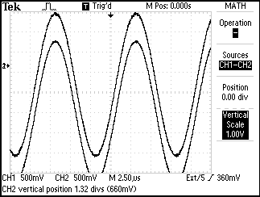 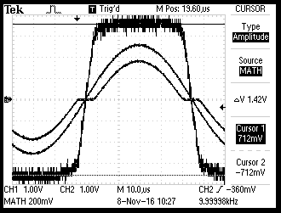

Graph : First solution to signal clipping

Graph :second solution to signal clipping. The thick line is the plot of the difference between the input and output signals.

The first circuit did a good job fixing signal clipping problem however a DC offset of 0.680V was introduced (nearly constant). This value is equivalent to the diode drop we measured earlier so as a limitation we cannot make this attempted solution be an ‘ideal’ emitter-follower circuit as we are offset by a constant amount which becomes more significant as the input voltage is decreased.

The second circuit also appeared to solve the problem pretty well however there is a visible flat period described to me by Dr. McIntyre to be a crossover affect due to the fact that we are using two transistors. I think this dead zone is due for values of Vin where |Vin|<diode drop as for these values neither transistor can be biased in such a way that current can flow to ground. Thus, if we could find transistors with lower diode drops we could further test to see if we can eliminate the problem. Again there is a difference between input and output voltages roughly equal to the diode drop. Between the two circuits it would seem then that the first is the better solution as we do not see the same flat zone at where the voltages go from negative to positive.

1. 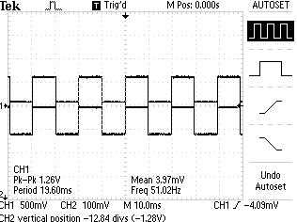*Transistor switch*

Figure 4: Input vs Output for LED driver circuit

1. **LED switch**: The final experiment had us build a circuit such that the transistor behaved like a switch, turning an LED on and off at a fixed frequency. Our first task was to measure the minimum amplitude required to get the LED to turn on. At 20 Hz, we found that the LED turned on when the amplitude was 1.2 Vpp so the input voltage was essentially 0.6 V – roughly equivalent to the diode drop for the transistor. Graph 6 shows the input waveform and the output waveform. As you can see, there is clearly a small square-wave on the output channel when the input is oscillating between + and – 0.6 Volts.

As we varied the frequency, we found that to the naked eye, we could still detect the blinking until the frequency reached around 40 Hz. After this frequency, the LED appeared to look a solid color with a brightness that increased as we increased the frequency. This is very reminiscent of Pulse Width Modulation used in many digital electronics to simulate analog signals.

Conclusions

In this lab we examined the various properties of the transistor. First we learned two different ways to determine the gain coefficient: the first was using the Hfe setting on the multi-meter (for those that have it) and the second was by using two ammeters to determine the ratio of output to input current for various inputs. The second experiment examined the behavior of the output signal through a transistor when the input is periodic. This resulted in an artifact known as signal clipping where if the emitter pin is grounded, the output signal will only display half of the behavior of the input signal. We then attempted to correct this by analyzing two possible solutions. Both were affected by the diode-drop across the base-collector pins and the second solution which utilized two transistors had a dead region of zero volts that appeared periodically. Finally the last experiment showcased how a transistor can behave like an electronic switch by using the input signal to turn an LED on and off. Again, everything was limited by the diode-drop which signified the minimum voltage (1/2 amplitude) required to be able to let current flow between the collector and emitter.

Works Cited

1. <https://www.google.com/url?sa=i&rct=j&q=&esrc=s&source=images&cd=&cad=rja&uact=8&ved=0ahUKEwjMhoaR_K7QAhXEjFQKHZhLDHIQjRwIBw&url=http%3A%2F%2Fwww.talkingelectronics.com%2Fprojects%2FBasicElectronics-1A%2FBasicElectronics-1A_Page2.html&psig=AFQjCNFP-eCSXlGPUfJW3NyH5Bklnw_P6g&ust=1479443876559729>
2. <http://physics.oregonstate.edu/~mcintyre/COURSES/ph411/ph411lab4.pdf>
3. <https://cdn.sparkfun.com/assets/learn_tutorials/4/2/3/2N3904.PDF>
4. <https://cdn.sparkfun.com/assets/learn_tutorials/4/2/3/2N3906.PDF>